**TEST ENVIRONMENT SET-UP**

Contents

Requirements 3

Installation Guide 3

Setting up VS Code 3

Getting to know the repository 4

Running the tests 4

# Requirements

*Below software should be downloaded and installed to your laptop prior to running the test.*

|  |  |  |
| --- | --- | --- |
| **Item** | **Purpose** | **Source** |
| Git for Windows / Mac | For version control | <https://git-scm.com/> |
| VS Code | IDE to run tests | <https://code.visualstudio.com/docs/setup/windows>  <https://code.visualstudio.com/docs/setup/mac> |
| NVM | To manage Node versions | <https://www.freecodecamp.org/news/node-version-manager-nvm-install-guide/> |
| Access to the repository | To run the tests | Github link |

# Installation Guide

* All the requirements above have its own installation guide.
* For simplicity, run the executable (.exe) file and follow through the process, then you’re good to go!

# Setting up VS Code

*Once requirements have been installed, VS code needs to have the right extensions to run the tests smoothly.*

1. Install Typescript.
   1. Click on “Terminal” > “New Terminal” in the Menu bar.
   2. Run npm install -D typescript

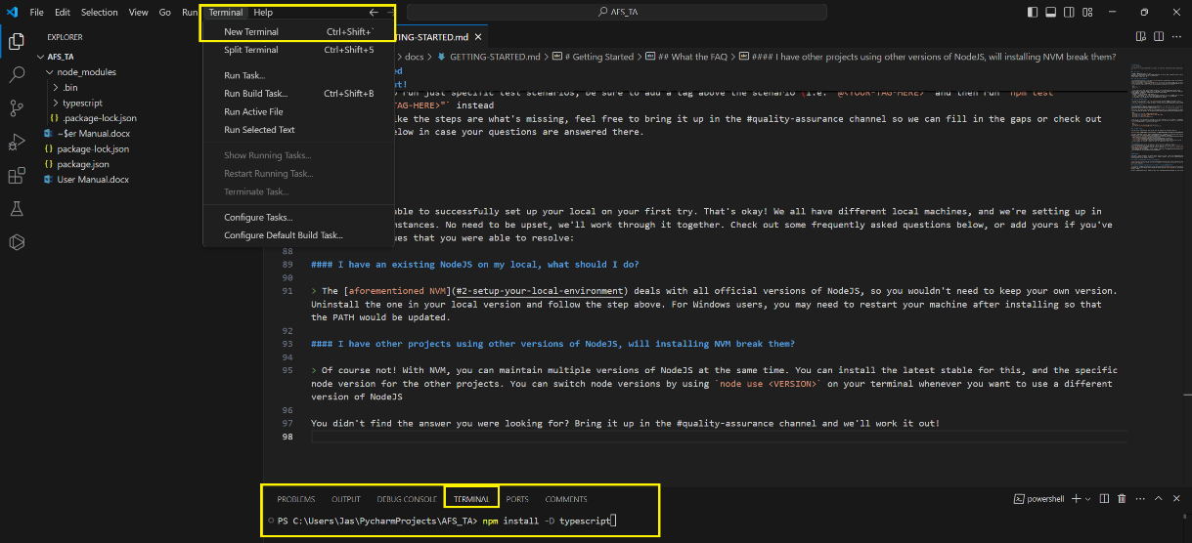

1. Install Playwright.
   1. Run npm init playwright@latest

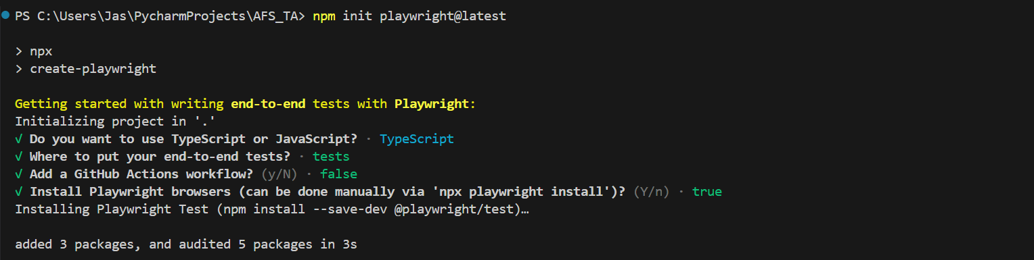

*You should be able to see* Happy hacking! 🎭 *at the end.*

1. You have set-up your IDE! Now it’s time to run tests.

# Getting to know the repository

*Before we dive in to the repository, cloning the repo is a must.*

1. Go to the repository.
2. Click on “Code”
3. Then copy the https URL.
4. Open File Explorer and navigate to the folder you want to clone the repository to.
   1. Create a folder to contain only the repository
5. Right click on the opened folder and click “Git Bash here”.
6. Type in “clone github link”

# Running the tests

* Head over the terminal and run npx playwright test
* If you want to see how the automation tests the app, run npx playwright test --headed